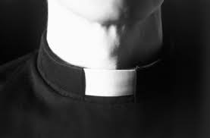

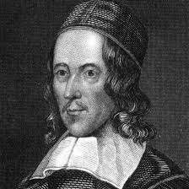



The Collar Poem by George Herbert

I struck the board, and cried, "No more!

I will go abroad.

What! shall I ever sigh and pine?

My lines and life are free; free as the road,

Loose as the wind, as large as a store.

Shall I still be in a suit?

Have I no harvest but a thorn

To let me blood, and not restore

What have I lost with cordial fruit?

Sure there was wine

Before my sighs did dry it; there was corn

Before my tears drowned it.

Is the year only lost to me?

Have I no bays to crown it?

No flowers, no garlands gay? all blasted?

All wasted?

Not so, my heart; but there is fruit,

And thou hast hands.

Recover all thy sigh-blown age

On double pleasures; leave thy cold dispute

Of what is fit and not; forsake thy cage,

Thy rope of sands,

Which petty thoughts have made, and made to thee

Good cable, to enforce and draw,

And be thy law,

While thou didst wink and wouldst not see.

Away! take heed;

I will go abroad.

Call in thy death's-head there; tie up thy fears;

He that forebears

To suit and serve his need

Deserves his load."

But as I raving, and grew more fierce and wild

At every word,

Me thoughts I heard one calling, "Child";

And I replied, "My Lord."